Summer:
Maldives: The Maldives has one of the most delicate environments anywhere on the planet. Coral reefs are the foundation of the islands. spend time engaging in exhilarating water activities, such as fishing, surfing, swimming, etc
- Cinnamon Velifushi Maldives (4.9) - Rs 62,660 per night
- Furaveri Maldives (4.6) – Rs 27,314
- Plumeria Maldives (4.6) – Rs 6,946

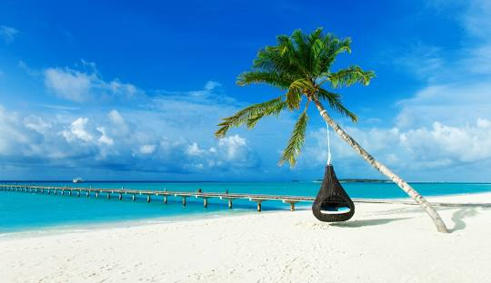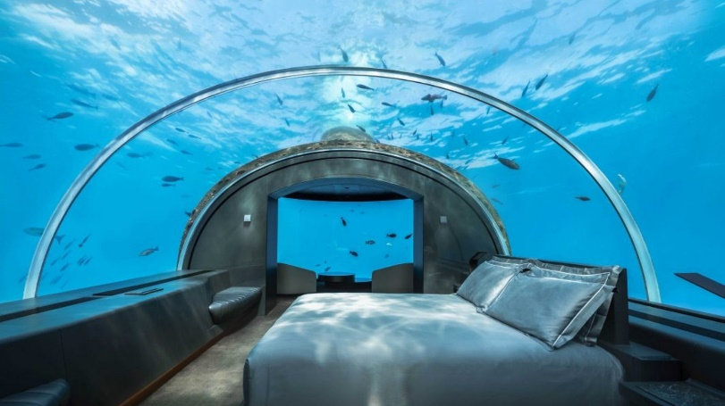

Hawaii: Discover the beauty, culture and adventures waiting for you on the Hawaiian Islands. Find Hawaii travel information and plan your perfect vacation.

Sensei Lanai, A Four Seasons Resort (4.7) - Rs 1,73,133

Marriott's Kaua'i Beach Club (4.5)- Rs 43,530

Waikīkī Grand Hotel (3.9)- Rs 14,975

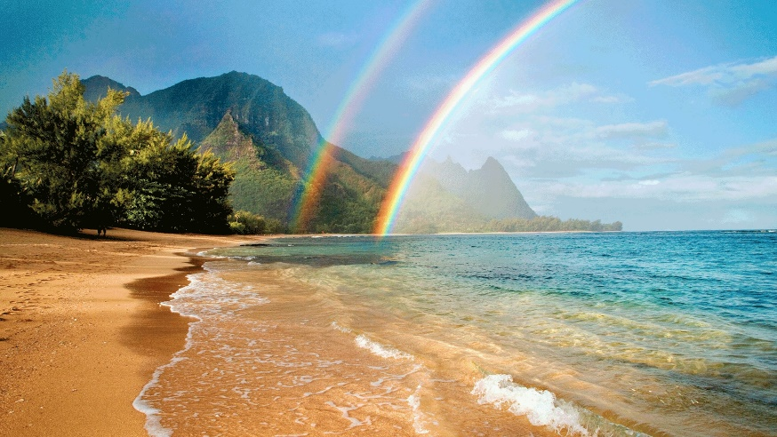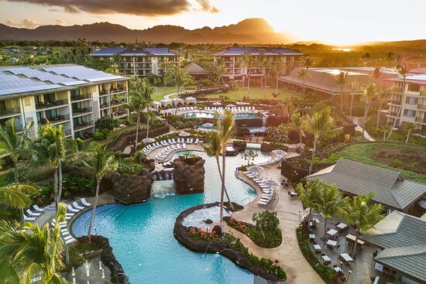

Kanyakumari: it is popular tourist destination and pilgrimage centre in India. Notable tourist spots include its unique sunrise and sunset points

Anantya By The Lake (4.4)- Rs 11,563

Isola Di Cocco (4.5)- Rs 5,625

Sparsa Kanyakumari (3.8)- Rs 4704

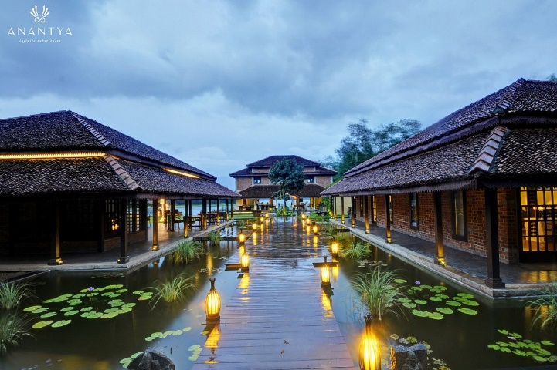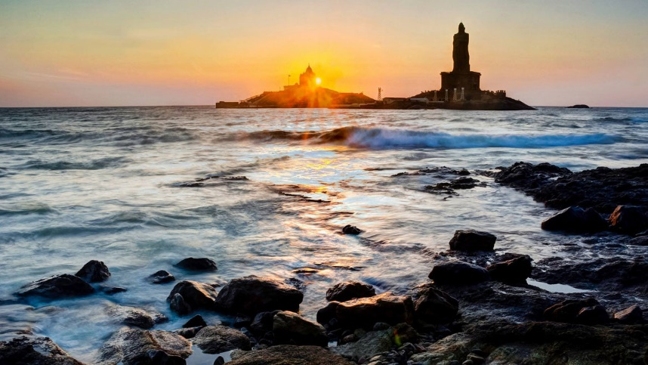

Bali:

Solia Legian Bali Hotel (4.5) – Rs 2,895

